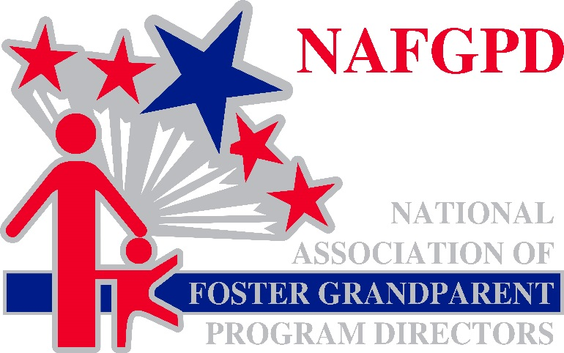
Honoring the Past. Envisioning the Future.
The National Association of Foster Grandparent Program Directors, Inc.(NAFGPD), was created in 1971. Since that time, NAFGPD has served as the principal advocate for the Foster Grandparent Program in general, for the furtherance of the goals of the Foster Grandparent Program (FGP), and for the well-being of its volunteers. The Association is incorporated in the State of Michigan and has a 509(a) status under IRS Code 501(c)3. *
Today NAFGPD represents members through educational, advocacy, and networking opportunities. The Board meets at least two times per year in Washington, D.C. to identify issues and propose solutions. Congressional visits are scheduled to the home states of Board Members, and a Washington, D.C. advocate tracks legislative and governance issues.

NAFGPD History
Viewed largely as demonstration or pilot projects since their inception in 1965, Foster Grandparent Programs were proving to be a solution to many of society’s issues surrounding both the aging population and young children with special needs. Foster Grandparent Directors were quickly being recognized as foot soldiers on the forefront of volunteering, and well-spoken authorities on providing opportunities for the aging population.
The 1971 White House Conference on Aging welcomed several Foster Grandparent Program (FGP) Directors as delegates from their respective states. Other FGP Directors also attended the conference as observers marking the first time that all Directors were gathered together in one place. After initially proposing to eliminate Foster Grandparent Programs, President Richard Nixon had recently formed the federal ACTION Agency combining both Foster Grandparents and RSVP which were Older American’s Act programs with VISTA, and the Peace Corps into one agency and expanded the budget for FGP from 10.5 million dollars to 25 million dollars.

Following the Conference, FGP Directors met to identify common challenges and issues that individual programs faced, as well as discuss the future hurdles that might be faced by the proposed expansion of FGP due to the establishment of ACTION and the increased budget recommended by President Nixon. Up until this meeting, an informal network of Directors had communicated with one another and had been invited to Washington, D.C. to discuss various proposals at the request of the Agency on Aging or ACTION. A need for a National Association to bring these concerns to federal officers and to provide guidance or advice on a host of issues was uniformly agreed upon in December 1971 and NAFGPD was formed.

One challenge that had been faced by programs in the first six years of existence was the fact that the Office of Economic Opportunity had been the initial home for the program, but in 1968 was transferred to the Department of Health, Education and Welfare. Program Directors were tasked with the responsibility of training the new agency. With the establishment of ACTION in 1971, Foster Grandparent Programs were once again being governed by a new group of managers, many of whom were former Peace Corps Volunteers or VISTA Volunteers with a commitment to volunteerism; but very little knowledge of Older American’s Programs or of the volunteers serving with them. Project Directors also reported that regulations were being interpreted differently around the country.
Current Reality: Programs still report that regulations are interpreted differently by each state office. NAFGPD will continue to advocate for more uniform application of the regulations and supports increased opportunities for both CNCS field officers and program directors to receive improved training and communication.
Stipend Increases
In 1979 Congress approved a stipend increase from $1.60 per hour to $2.00 per hour even though agency officials were only advocating for an increase to $1.80 per hour. The increase is widely considered to be the first legislative victory for NAFGPD; but most importantly it was a victory that benefitted Foster Grandparents.
In 2009 the Kennedy Serve America Act specified a stipend increase for Foster Grandparents and Senior Companion Program members from $2.65 per hour to $3.00 per hour. While authorized to increase the stipend to $3.00 per hour, a coordinated push to secure the increase has not yet materialized.
Current Reality: NAFGPD maintains that this increase that directly benefits our Grandparents is long overdue and we believe that there must be a commitment on the part of CNCS to seeing this implemented.

Changes to the “80/20” Rule
Foster Grandparent Programs and NAFGPD have long advocated for a change in the “80/20” rule with the first documented issue being raised in 1981. Arguments against a change in this formula have been made that the program is much more “saleable” to Congress if it doesn’t show high program support costs. NAFGPD notes that program support costs continue to rise; which has proven difficult for sponsors to maintain the necessary staff to operate high quality programs. In addition to limited staff, increased mandates and changing programmatic priorities deter from the focus of the volunteers and their service to the community.

Current Reality: CNCS proposed changes to the 80/20 rule in 2016; however, no details were provided at that time as to what those changes would look like. NAFGPD supports modifying the Direct Benefit percentage; but does not advocate for it to be eliminated entirely.

National Service Criminal History Checks
NAFGPD supports the institution of NSCHC as defined by the Edward M. Kennedy Serve America Act. We believe that vulnerable populations should be protected and a first line of defense is a multi-faceted criminal history check. NAFGPD strongly supports a national vendor criminal history check system. Sponsoring agencies have continually expressed their concerns regarding training, communication, execution and oversight of NSCHC across the nation, siting the confusion created by the differing processes in place based upon state laws and processes.

The current compliance monitoring system does little to mitigate the real issue of not placing volunteers who are in violation of the NSCHC policies since many times a volunteer has already completed service before a compliance visit identifies an issue with the check.

Program Sponsors should not incur fines, paid to CNCS from local community funds, when minor infractions such as spelling errors, simple name variations, or lack of printed dates are identified.

Current Reality: CNCS State Program Offices do not serve as the front line NSCHC trainers for programs in the field. Frequent turnover in sponsor/program staff is a reality due to the loss of hard earned local funds that would otherwise be used to provide Direct Benefits to volunteers. New Directors report taking over grants facing programmatic, financial, and emotional stress due to the process; and unfortunately, have no guidance from state offices or CNCS in general to improve compliance.

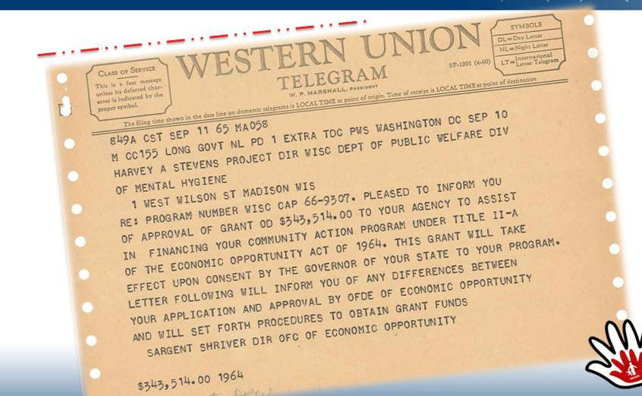

Our Focus and Mission is to
Advocate Nationally. Succeed Locally.
With this Mission in mind NAFGPD:
- Sponsors a networking list-serve exclusively for association members. The electronic bulletin board enables members to reach out to fellow Directors for advice and suggestions.
- The Board is comprised of an Executive Committee and representatives from each of the five regional clusters, all of whom are professional members of the association.
- Maintains a professional relationship with each of the fellow associations representing Senior Corps programs; however, our focus remains on Foster Grandparent Programs and the Directors who manage them.
- Encourages our members to share questions and concerns from the field which may be conveyed to CNCS staff as appropriate. We avoid advocating for individual program issues; however, we do seek to identify common questions and problems that are faced throughout the country and bring them to the attention of Senior Corps officers.
- Sponsored the first association sponsored and CNCS sanctioned Senior Corps Foster Grandparent Director’s conference in Kansas City in 2013. This event brought together Directors and staff from throughout the country for training specific to Foster Grandparent staff.
- Sponsored a Senior Corps training event in Reston, Virginia to celebrate the 50th Anniversary of Foster Grandparent Programs. Dr. Bernie Nash, who wrote the original legislation establishing the program and signed by President Lyndon Johnson in 1965 attended the event and shared insights into the creation of the program as part of the War on Poverty.
- Lead sponsor in cooperation with fellow Senior Corps Associations in a 2016 Senior Corps Conference which observed the 45th Anniversary of RSVP.
- Presented Workshops at each of the 2017 National Service Regional Training Events.

We Believe:
- Members have a right to share their questions, opinions, and frustrations in an environment of trust and support.
- Members should have a voice to speak for them when issues that affect the field and program management are widespread and detrimental to programs.
- Members should expect that the NAFGPD Board of Directors will represent them professionally and with respect for all opinions; and will work with Federal Program Officers to benefit Programs, Grandparents, and the communities where they serve.
- Professional Representation in Washington, D.C. is essential to the success of Foster Grandparent Programs.

NAFGPD held a Strategic Planning Retreat in July 2017 to map out a future for the association that respects the history of Foster Grandparent Programs while envisioning a future that will continue to respect the talents and abilities of our low-income service members while also creating a brighter future for our communities.

